Name: Phạm Đức Đạt

ID: ITITIU20184

Deploy link: <https://ducdatit2002.github.io/wad-lab1/>

1. index.html

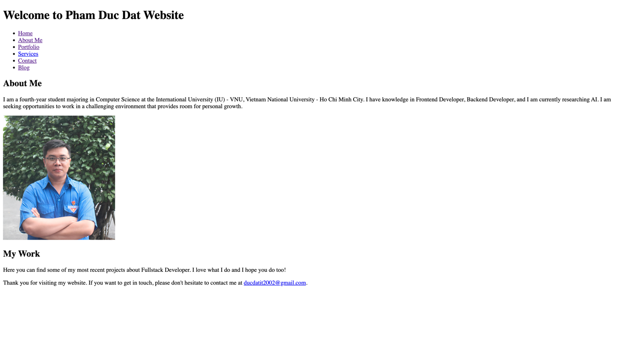

1. about.html

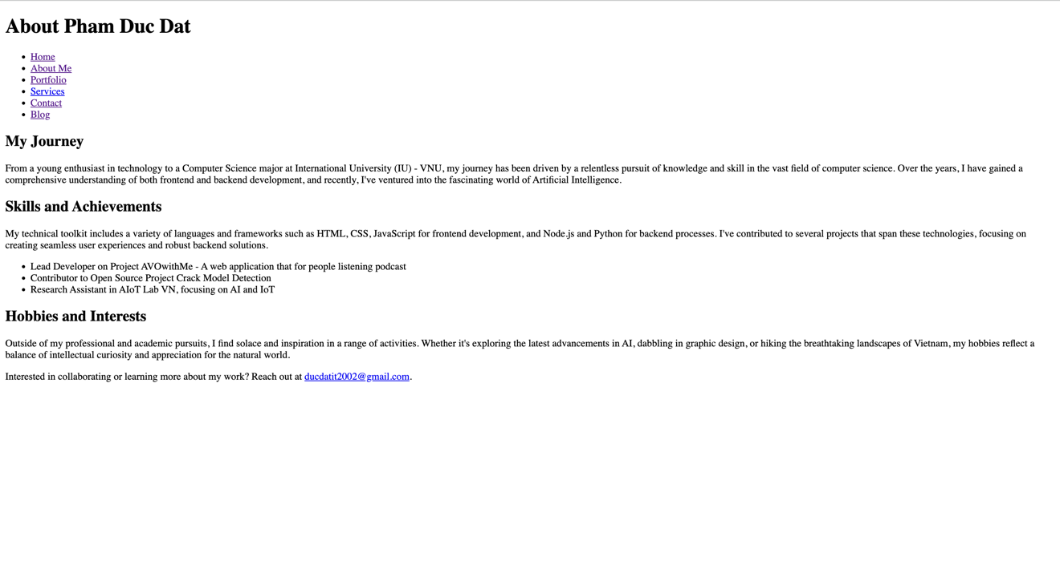

1. portfolio.html

1. project1.html

1. project2.html

1. project3.html

1. Service.html

1. Contact.html

1. Blog.html

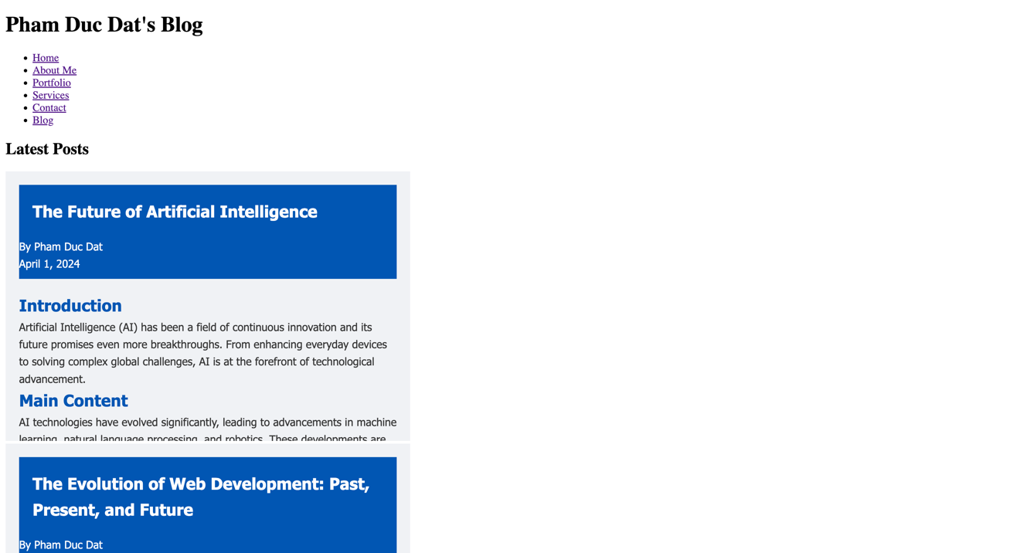

1. Post1.html

1. Post2.html

